Enterprise Network ITNW 2350

Lab 3.1.1c

GYIMP

Jacob Calvert, Timothy Zellers, Regan Stubbs, James Baker, Faustino Gonzolez

Criteria #1 DMZ FTP Server: Provide configuration proof of FTP file system and ACLs (i.e Binding of ftp site to DNS name, path to ftp site documents directory, working FTP site)

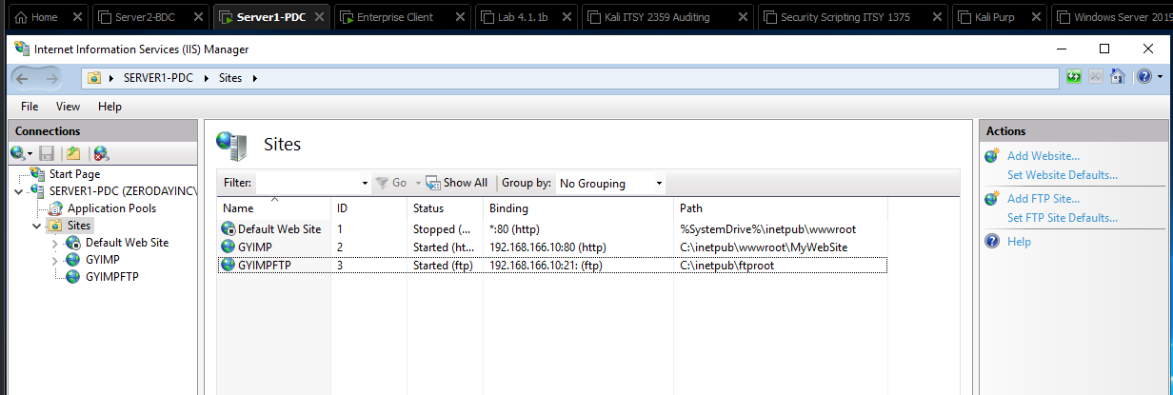

Criteria #2 DMZ Web Server: Provide configuration details website: ACLs bindings, document directory – showing initial / default webpage name, bindings, working website. (Note: If you used IIS provide screenshot of Sites showing site name, status, binding and path; if using Linux provide screenshots of directives of .conf files showing the above information)

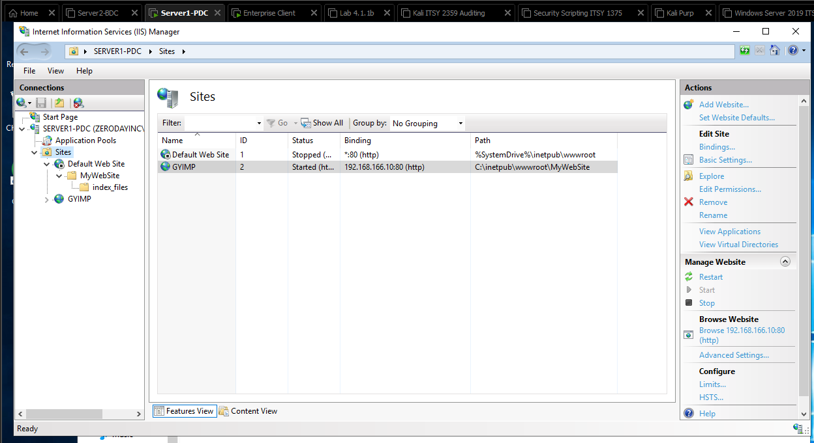

Criteria #3 Internal Web Server: Provide configuration details website: ACLs bindings, document directory – showing initial / default webpage name, bindings, working website. (Note: If you used IIS provide screenshot of Sites showing site name, status, binding and path; if using Linux provide screenshots of directives of .conf files showing the above information)



Criteria #4 DNS forward zone records showing A records used for the ftp and web sites.

